Working Group 3

Author : |  | Christian GIRAUD |  | Date : | 08/10/2014
Subject : |  |  |  |  |  |  | Document Review : |  | ☑
OpenETCS WP3 Task Force |  |  |  |  |  |  | Design Review : |  | ❒
WG 3 Architecture - provisional - |  |  |  |  |  |  | Other :

Name | Position | Company / Department
Valerio Raimondi |  | Alstom
Stephane Besure |  | Alstom
Nicolas Boverie |  | Alstom
Christian Giraud |  | Alstom
Yoann Guyot |  | Cetic
Baseliyos Jacob |  | DB
Bernd Hekele |  | DB
Niklas Schaffrath |  | Siemens
Uwe Steinke |  | Siemens
Jos Holtzer |  | NS
Jan Welvaarts |  | L’loyds Register Rail
Sylvain Baro |  | SNCF
Marielle Petit-Doche |  | Systerel
Jan Welte |  | TU Braunschweig

Distribution to:
Name | Position | Company / Department
datadictionary@openetcs.org;  openETCS srs-analysis@openetcs.org |  | Alstom TIS

Table of Content

1. Objectives and strategy 5
2. Context Of Open-ETCS 6
2.1 references 6
2.2 High Level Architecture 6
2.3 Concept Of Open ETCS 7
2.3.1 Unisig Specification 8
2.3.2 Signalling Application Specification 8
2.3.3 Formal Specification 8
2.3.4 Model 8
2.3.5 Kernel Code 8
2.3.6 Virtual Machine 8
2.3.7 Host Machine 8
2.3.8 Real Time Machine 8
2.3.9 Validation 8
3. Data for Safe Movement 9
3.1 General 9
3.2 Linking and Re-Positioning 9
3.3 Basic Track Description 11
3.3.1 Movement Authority 11
3.3.2 Standard Speed Profile 11
3.3.3 Gradients Profile 12
3.4 Optional Track Description 12
3.5 Other Track to Train Data 14
3.6 Radio Communication with RBC. 15
3.6.1 Train To Track Packets for Radio 15
3.6.2 Track to Train Message 15
3.6.3 Train To Track Radio Message 16
3.7 System Data 17
3.7.1 Fixed Values 17
3.7.2 National Values 17
3.7.3 Train Data 17
3.7.4 Additional Data 18
3.7.5 Date and Time 18
3.7.5.1 UTC 18
3.7.6 Data view 18
4. Processes Over Data 23
4.1 Data Preliminary Operation 23
4.2 Storage of Data 26
4.3 Update of Data 28
4.4 Train Positioning and linking 28
4.5 Emergency Stop 32
4.6 Speed and Distance Monitoring 32
4.6.1 Computation of Deceleration and Brake Build up Time 32
4.6.2 MRSP computation 32
4.6.3 Computation of Target and Curves 32
4.6.4 Supervision Limits Computation 32
4.6.4.1 Ceiling Speed Monitoring 32
4.6.4.2 Target Speed Monitoring 32
4.6.4.3 Release Speed Monitoring 32
4.7 Protection against undesirable movement 32
4.7.1 Roll Away 32
4.7.2 Reverse 32
4.7.3 Standstill 32
4.8 Mode Management 32
4.9 Brake command handling 32
4.10 Special Function 32
4.11 Version Management 32
5. SysML First Draft 33
5.1 First Level IBD 33
5.2 Second Level 34
5.3 To Position Train 41
5.4 To Achieve Processes 43
5.5 Breakdown Structure of EVC 44
5.5.1 General 44
5.5.2 First Level 44
5.5.3 Second Level 44
6. Development of A5.1 ( example) 46
6.1 references 46
6.2 overview 46
6.3 Context of Speed and Distance Monitoring 46
6.4 Example of Balise Group in level 1 48
6.5 EB Supervision Curve 48
6.6 EB Supervision Computation 49
6.7 EB Supervision Excel File 50
6.8 EB Supervision per Quantum 53
6.9 Additional Issue on EB Supervision per Singular Point 56

Objectives and strategy
The main objective is to propose a technical plan for Open-ETCS in relation with UNISIG specification.

The aim of Open-ETCS is to insure that “Subset_026 version_3.3.0” shall be implemented and interpreted following the same understanding by every supplier of ETCS devices.

Given the difficulties, it has been defined that consists in working on application software of EVC. Trackside application software is anticipated as enough transparent from EVC.

Three phases are involved :

- First Phase : The Subset-026 chapter3 being basically a system requirement definition, it needs to be analysed and structured through SysML methodology or equivalent. That permits to build a breakdown structure as follows :
  - Basic Software and hardware, is proprietary software of each ETCS supplier,
  - Application Software (so-called “kernel software”),
    - Balise Data storage and update,
    - Positioning,
    - Speed Control Monitoring,
    - etc..
  - Application Program Interface : Alstom solution is acting as reference.

- Second Phase : The Breakdown Structure of Application Software is refined up to reach a level of detail that permits to proceed to a formal (non ambiguous) specification and encoding.
  - This phase leads to include most of the modules within the Open-ETCS library.
  - On a first step, it has been agreed to work on “Balise Data Storage” and “Positionning”.
  - It may appear the need to define a database structure when study of other functions.
  - At the end of this phase, “Kernel Software” is ready for integration on “Host Machine” or on “Real Time Machine”.

- Third Phase : In order to consolidate the specification, a model is developed for the most complex functions that permits to get a reference for each signalling implementation. This is the concept of Virtual Machine.

Context Of Open-ETCS

references
UNISIG Subset_026 version_3.3.0
Chapter 3 : ERTMS / ETCS Principes
Chapter 5 : ERTMS / ETCS Procedures
Chapter 7 : ERTMS / ETCS Language

High Level Architecture
The following Block Diagram Definition (BDD) gives an abstract of global ETCS from the on-board (EVC) point of view :

Balise
Odometry
DMI
TIU
CORE
Radio
(RBC)
EVC

Block Diagram Definition

EVC is composed of :
- Balise reception
- Odometry
- DMI : Display Man Interface
- TIU : Train Interface Unit
- CORE : Computer
- Radio sub-system (GSM) and RBC (Radio Block Center)
- Euroloop (optional)
- Recorder Unit

Communication are insured through a triple Bus (CAN bus for instance).
Specification of communication are defined by API (Application Program Interface) from functional point of view.

Concept Of Open ETCS
Open ETCS aims to provide a link between the UNISIG Specification (Mainly Subset_026) and any implementation of On-board provider.

For reaching this challenge, a double activity diagram is proposed as follows :

Unisig Specification V3.3.0
Formal Specification
(SysML & Software Spec)
Model
Kernel Code
Host Machine
(Soft ADA C++)
Real Time Machine
(hard +soft + simu)
Virtual Machine
( Excel )
Signalling Implementation Specification
Validation
Hardware + basic soft + simulator

Block “Actigram”

This actigram shows the 3 branches of activity that are involved in order to validate any Signaling Application.

Unisig Specification
The main document of reference is the subset 026 in version V3.3.0.
All chapters are applicable and all subset that are referenced in it.

Signalling Application Specification
The Signalling Application Specification should include :
- track layout with balise group (BG) and signals,
- definition of each BG coverage, in normal and reverse direction if needing,
- definition of mandatory data for each BG,
- definition of optional data for each BG,
- definition of system data.

Formal Specification
The Formal Specification shall include two steps :
- SysML defines the architecture & Software Spec,
- Formal language specifies the software or can be used as retro engineering.

Model
The use of “Excel” is a solution to study braking curves of each signal and for a run of a virtual train.
Other solution ?

Kernel Code
Programing language : ADA vs C++.
Formal language : B language.
Bridge to pass from B to ADA.

Virtual Machine
Excel, solution linked to Model.

Host Machine
Solution to compare result with virtual machine.

Real Time Machine
Idem Host.

Validation
Automatic validation is interesting for checking in case of software updating.

Data for Safe Movement

General
This chapter aims to provide an overview of EVC Data Packets and Variables following the definition hereafter :
- Data Packets related to Linking,
- Data Packets related to basic track description,
- Data Packets related to optional track description,
- Data Packets and Variables related to radio communication with RBC,
  - Additional Data Packets for radio communication
  - Track To Train Radio Data Messages,
  - Train To Track Radio Data Messages.

All Data are structure of variables as defined hereafter (see Subset-026, chapter 8) :

- A Telegram is a set of Packet transmitted through one balise which includes a “header”,

- A Balise Message is a set of all Telegrams of a BG,

- A Radio Message is a set of Variables and Packets transmitted through GSM_R and includes a “header”,

- A Packet is a set of variables which may include option and repeating.

“Linking” versus “Linked” and Re-Positioning

Definition
“Linking” data are playing a major role in management of track description, that is :
- To know in advance which BG will be met from any current BG (several BG can be defined),
- To check the train position regarding the window related to the last BG position,
- To check the train position regarding the route provided by the previous BG,
- To up-date the track description provided by the previous BG,
- To reduce the train position error to the position inaccuracy of the last BG,
- To permit or not an immediate reaction in case of BG missing.

But the use of linking is only an option of design, and depending on the confidence in odometry. As result, “Linking” is submitted to a qualifier meaning “Linking Use” or “Linking Not Used”. All information about “Linking” are given and described within SRS chapter 3-4-4.

“Linked” is a qualifier included within the header of any balise group and which defines the nature of data that are included in it :

- “Linked” means that BG :
  - can be announced in the current LRBG to up-date data.
  - can become the new LRBG if consistent with opened window,
  - can be not announced but may still become the new LRBG without checking.
  - if not announced, position is given by train position and current LRBG.
- “Unlinked” means that BG :
  - can be announced in the current LRBG, to provide additional data.
  - cannot become the new LRBG even if consistent with opened window,
  - can be not announced but may still provide additional data.
  - if not announced, position is given by train position and current LRBG.

Re-Positioning is involved to reduce positioning error when needing.

Linking is defined by packet 5 for all level
Linked / Unlinked is defined by one header qualifier.

Repositioning is defined by packet 16 :
- only through balise in 1 level.

True Table

When “Linking” is used, the true table is :

LINKING USE on-board | Linked BG | Unlinked BG
Linking exists in message | Window is computed  Train Position is checked  BG becomes LRBG if checking OK  & Downstream Data are up-dated | Window is computed  Train Position is checked  Additionnal Data are stored if checking OK
No Linking in message | No action | Additionnal Data are stored

When “Linking” is not used, the true table is :

LINKING NOT USE | Linked BG | Unlinked BG
Linking exists | Train Position gives BG position  BG becomes LRBG  & Downstream Data are up-dated | Train Position gives BG position  Additionnal Data are stored
No Linking | Train Position gives BG position  BG becomes LRBG  & Downstream Data are up-dated | Train Position gives BG position  Additionnal Data are stored

Basic Track Description
“Movement Authority”, “Standard Speed Profile” and “Gradient Profile” are the basic element for a Track Description. These data are provided by “Linked BG” or “Un-Linked BG” or by Radio.

Movement Authority
- Section : the MA is composed of several section with optional timer to enter,
- LOA : is the length of MA starting from LRBG, and is terminated by EOA,
  - must be covered by SSP and Gradient Profile,
- DP : Danger Point is beyond the EOA and permits to approach EOA,
- OL : Overlap is beyond the EOA and requires a locking from some other routes.
- Veoa : is the limit speed related to EOA.
- Vsig : is the maximum speed over MA level 1.
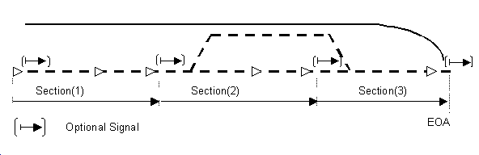
MA level 1 is defined by packet 12 through balise (includes Veoa).
MA level 2/3 is defined by packet 15 through radio (no Veoa).

Standard Speed Profile
SSP is a continuous profile defined by a set of : {distance, value}.

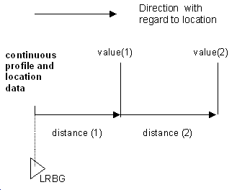
SSP is defined by packet 27 through balise in level 1.
SSP is defined by packet 27 through radio in level 2/3.

Gradients Profile
Gradient Profile is a continuous profile defined by a set of {distance, value}.
Gradient Profile describes the worst case of grade over the maximum length of train, as follows :
- Unit is 1/1000,
- Value positive for up-hill,
- Value negative for down-hill.
Gradient Profile is defined by packet 21 through balise in level 1.
Gradient Profile is defined by packet 21 through radio in level 2/3.

Optional Track Description
The following packets are related to control speed (See Subset-026, Chapter 3.11).

- Axle Speed Profile is defined through packet 51.

- Level Transition Order is defined through packet 41.

- Conditional Level Transition Order is defined through packet 46.

- Temporary Speed Restriction is defined through packet 65.

- TSR Revocation is defined through packet 66.

- Adhesion factor is defined through packet 71.

- Mode Profile and Related Speed Restriction is defined through packet 80.

- LX Speed Restriction is defined through packet 88.

- Speed Restriction to ensure Permitted Braking Distance is defined through packet 52.

- Track Ahead Free is defined through packet 90.

The following packets are related to DMI (See Subset-026, Chapter 3.12).
- Track Conditions are defined through packet 39, 40, 67, 68, 69.
- Route Suitability is defined through packet 70.
- Text Transmission is defined through packet 72 & 76.
- Geographical Position is defined through packet 79.

Other Track to Train Data
Most of the following packets are inserted in radio messages and used for miscellaneous functions (See subset-026, chapter 4.8.3).

- Virtual Balise Cover ( packets 0 & 6 ).
- Version ( packet 2 ).
- National Values ( packet 3 ).

- SR Distance from loop ( packet 13 ).
- Session Management ( packet 42 ).
- Radio Network Registration ( packet 45 ).
- List of Balises for SH ( packet 49 ).
- List of Balises for SR ( packet 63 ).

- MA Request Parameters ( packet 57 ).
- Position Report Parameters ( packet 58 ).
- Inhibition of revocable TSR ( packet 64 ).

- RBC Transition Order( packet 131 ).
- Danger for SH ( packet 132 ).
- Radio Infill Area Info ( packet 133 ).
- End Of Loop Management ( packet 134 ).
- Stop Shunting ( packet 135 ).
- Infill Location Reference ( packet 136 ).
- Stop if in SR Mode ( packet 137 ).
- Reversing Area Information ( packet 138 ).
- Reversing Supervision Information ( packet 139 ).
- Train Running Number from RBC ( packet 140 ).
- Default Gradient for TSR ( packet 141 ).
- Session Management with RIU ( packet 143 ).
- Inhibition of BG consistency reaction ( packet 145 ).

- Default Balise / Loop / RIU ( packet 254 ).
- End of Telegram / Message ( packet 255 ).

Radio Communication with RBC.
The Radio Communication messages are described in 2 tables hereafter (See subset-026, chap 4.8.3 & chap 3.8.3).

The Radio Communication with the RBC involves Radio Messages in both direction (Train To Track and Track To Train) and uses the same variables as those of Balise Communication.

Then, a list of new Data Packets is defined in order to address the “Track To Train” radio message.

Train To Track Packets for Radio
- Position Report ( packet 0 ).
- Position Report based on two balise groups ( packet 1 ).
- Onboard telephone numbers ( packet 3 ).
- Error Reporting ( packet 4 ).
- Train running number from EVC ( packet 5 ).
- Level 2/3 transition information ( packet 9 ).
- Validated train data ( packet 11 ).
- Data used by applications outside the ERTMS/ETCS system ( packet 44 ).
- End of Telegram / Message ( packet 255 ).

Track to Train Message
Common packet list = 3, 5, 39, 40, 41, 42, 44, 45, 51, 52, 57, 58, 64, 65, 66, 68, 69, 70, 71, 72, 79, 88, 131, 138, 139, 140.

Mess. Id. | Message Name | From | Packets / Variables  ( OP = optional packets)
2 | SR Authorisation + optional list | RBC | T_TRAIN, M_ACK, NID_LRBG + OP + D_SR  ( OP = 63 )
3 | Movement Authority | RBC | T_TRAIN, M_ACK, NID_LRBG + OP + 15  ( OP = 21, 27, 49, 80, + common )
6 | Recognition of exit from TRIP mode | RBC | T_TRAIN, M_ACK, NID_LRBG
8 | Acknowledgement of Train Data | RBC | T_TRAIN, M_ACK, NID_LRBG + T_TRAIN of train
9 | Request to Shorten MA | RBC | T_TRAIN, M_ACK, NID_LRBG + OP + 15  ( OP = 49, 80 + common )
15 | Conditional Emergency Stop | RBC | T_TRAIN, M_ACK, NID_LRBG + D_EMERGENCY + NID_EM
16 | Unconditional Emergency Stop | RBC | T_TRAIN, M_ACK, NID_LRBG + NID_EM
18 | Revocation of Emergency Stop | RBC | T_TRAIN, M_ACK, NID_LRBG + NID_EM
24 | General message | RBC, RIU | T_TRAIN, M_ACK, NID_LRBG + OP  RBC : ( OP = 21, 27 + common )  RIU : ( OP = 45, 143, 254 )
27 | SH Refused | RBC | T_TRAIN, M_ACK, NID_LRBG + T_TRAIN of train
28 | SH Authorisation + optional list | RBC | T_TRAIN, M_ACK, NID_LRBG + T_TRAIN of train + OP ( OP = 3, 44, 49 )
32 | RBC/RIU System Version | RBC, RIU | T_TRAIN, M_ACK, NID_LRBG + M_VERSION
33 | MA with Shifted Location Reference | RBC | T_TRAIN, M_ACK, NID_LRBG + OP + D_REF + 15  ( OP = 21, 27, 49, 80, + common )
34 | Track Ahead Free Request | RBC | T_TRAIN, M_ACK, NID_LRBG  + D_REF + D-TAF + L_TAF
37 | Infill MA | RIU | T_TRAIN, M_ACK, NID_LRBG + 12 + 136
38 | Initiation of a communication session | RBC | T_TRAIN, M_ACK, NID_LRBG (unknown)
39 | End of communication session  Acknowledgement | RBC, RIU | T_TRAIN, M_ACK, NID_LRBG
40 | Train Rejected | RBC | T_TRAIN, M_ACK, NID_LRBG
41 | Train Accepted | RBC | T_TRAIN, M_ACK, NID_LRBG
43 | SoM position report confirmed by RBC | RBC | T_TRAIN, M_ACK, NID_LRBG
45 | Assignment of coordinate system | RBC | T_TRAIN, M_ACK, NID_LRBG  + Q_ORIENTATION

Train To Track Radio Message

Mess. Id. | Message Name | Toward | Packets / Variables  ( OP = optional packets)
129 | Validated Train Data | RBC | T_TRAIN, NID_ENGINE + 0 / 1 + 11
130 | Request for Shunting | RBC | T_TRAIN, NID_ENGINE + 0 / 1
132 | MA Request | RBC | T_TRAIN, NID_ENGINE + 0 / 1  + (OP = 9) + Q_MARQSTRESON
136 | Train Position Report | RBC, RIU | T_TRAIN, NID_ENGINE + 0 / 1 + OP= 4, 5, 44
137 | Request to shorten MA is granted | RBC | T_TRAIN, NID_ENGINE + 0 / 1  + T_TRAIN of request
138 | Request to shorten MA is rejected | RBC | T_TRAIN, NID_ENGINE + 0 / 1  + T_TRAIN of request
146 | Acknowledgement | RBC, RIU | T_TRAIN, NID_ENGINE  + T_TRAIN of acknowledged message
147 | Acknowledgement of Emergency Stop | RBC | T_TRAIN, NID_ENGINE + 0 / 1  + NID_EM + Q_EMERGENCYSTOP
149 | Track Ahead Free Granted | RBC | T_TRAIN, NID_ENGINE + 0 / 1
150 | End of Mission | RBC | T_TRAIN, NID_ENGINE + 0 / 1
153 | Radio infill request | RIU | T_TRAIN, NID_ENGINE + 0 / 1  + NID_C + NID_BG + Q_INFILL
154 | No compatible version supported | RBC, RIU | T_TRAIN, NID_ENGINE
155 | Initiation of a communication session | RBC, RIU | T_TRAIN, NID_ENGINE
156 | Termination of communication session | RBC, RIU | T_TRAIN, NID_ENGINE
157 | SoM Position Report | RBC | T_TRAIN, NID_ENGINE + 0 / 1 + Q_STATUS  + OP= 4, 5, 44
158 | Text message acknowledged by driver | RBC | T_TRAIN, NID_ENGINE + 0 / 1  + NID_TEXTMESSAGE
159 | Session Established | RBC, RIU | T_TRAIN, NID_ENGINE + OP

System Data
See subset-026 chap3.18.

Fixed Values
Data are defined in basic software before a compilation.

National Values
Data are transmitted with “Country Number” through packet 3 :
- by balise for all levels,
- by radio for level 2/3.

Train Data
Data must be defined at standstill, before a mission :
- Train category(ies)
- Train length
- Traction / brake parameters
- Maximum train speed
- Loading gauge
- Axle load category
- Traction system(s) accepted by the engine
- Train fitted with airtight system
- List of National Systems available on-board
- Intentionally deleted
- Axle number

Additional Data
Data are provided through DMI :
- Driver_ Id
- ETCS level
- Radio Network identification
- RBC Identification
- Telephone Number
- ETCS Identity
- Train Running Number
- Adhesion factor

Date and Time

UTC

Data view
TBD.

Preliminary Data Architecture
As a conclusion of this chapter, we describe a preliminary architecture of stored data with the following objectives :
- To distinguish data associated with speed control and data additional that are involved in secondary function,
- To distinguish linked balise with unlinked balise,
- To facilitate storage of data coming from balise and radio,
- To make easy the computation associated to speed control..

This preliminary description is achieved into several steps in order to facilitate understanding.

Step 0 : Odometry Principles description

Odometry Model and Train Position Correction are described by a drawing as hereafter :

C2max
C2nom
C1max
C2min
C1nom
C1min
BG1
T2 -> BG2
C0nom
Distance between 2 BG to be compared to D_Link if linking available

Comments :
- Odometry provides a coordinate system through three counters of 32 bits with sign.
- These counters are vital and are set to value “0” on power-up.
- These counters can increase or decrease following train orientation.
- These counters re-start with the nominal value when overpassing a BG.

Step 1: set of LRBG :
At this step, we suppose train is meeting only “Linked Balise” and “Linking” is used.
All linked BG become LRBG and the Database is fill-up as described hereafter :

LRBG_n-1
LRBG_n
LRBG_n+1
D_link_1
D_link_2
D_link_3
Delay
Train_Position (C-Nom )
Window Acc
Window ( C-Min / C-Max )

Comments :
- Balises must be of type “linked” to become LRBG, unlinked balise cannot become LRBG.
- If Linking was not used, LRBG position should be given by train position when passing over balise without checking.
- As Linking is used, LRBG position is given by “D_LINK” of package “linking” and train position is checked and restored accordingly with calculated LRBG position.
- If no Linking is provided ( that is linking list dos’nt contain the linked balise group), the “Linked Balise” are ignored.
- “Unlinked Balise” are always taken into account.
- Condition of acceptance for Train_Position :
  - D_link + ½ Window-Acc > Train_Position > D_link - ½ Window-Acc
- Condition of acceptance for D_Link :
  - C-Max > D_Link > C-Min
  - New Train_Position = dbgcenterdetection

Step 2 : set of Unlinked Balise or linking not used :
At this step, we suppose :
- Train is meeting “Unlinked Balise”, or,“Linking” is not used.
In any case, the result is :
- BG cannot become LRBG,
- There is no D_Link excepted if packet 16 is provided,
- BG position is given by train position,
- Associated data are stored with train position as reference.

The Database is fill-up as described hereafter :

LRBG_n-1
BG_n
BG_n+1
??
D_lin
Delay
Actual Train_Position

Comments :
- Train receives several Unlinked BG in downstream of LRBG_n-1.
- If “Linking” is not used, the position of Unlinked BG is :
  - D_link = Train_Position – Delay
  - All packets are stored as they are received.
  - Packets are stored at LRBG level (because in harmony with radio message).

Step 3 : set of Packets :
At this step, we deploy all packets that have been stored within each LRBG.

Packets are broken into several “events” that need to be positioned relating to LRBG.

Event_Position = ( Packet_Position_relating_LRBG ) + ( Event_Position_relating_packet )

We suppose that enough passed LRBG are stored to trake into account all anticipated constraints in downstream of current train position.

The Database is fill-up as described hereafter :

LRBG_n
Delay
Train_Position
Event_n1
Event_n2
Event_n3

Comments :
- Event “n1” has been overpassed and cannot be swept, excepted by turning buffer process.
- Event ”n2” & “n3” are events to come and may be swept and replaced every time memorized packets are changing.

Step 4 : Radio Message :

It is anticipated that Radio Communication behaviour is identical to multiple fictive and ”unlinked” balise.

Step 5 : Inaccuracy Issues
Inaccuracy issues arise when changing of reference.
Let be the handover between two BG providing the same EOA.

BG_1
BG_2
LOA_1
LOA_2
EOA_1
D_link
ERR
EOA_2

- The BG_1 provides the target EOA_1 defined through the MA length LOA_1.
- The BG_2 provides the target EOA_2 defined through the MA length LOA_2.

Position of BG_1 and BG_2 are defined by D_link with an inaccuracy of +/- Loc_Acc for each BG.

Length of LOA_1 and LOA_2 are defined at “data preparation” level without inaccuracy.

The issue is how to have always : Maximum of “EOA_1 position” < Minimum of “EOA_2 position”
Considering that condition avoids any restrictive situation when approaching the target.

With BG_1 position taken as reference and Loc_Acc is the global accuracy related to BG reading.

Maximum of “EOA_1 position” = LOA_1 + Loc_Acc

Minimum of “EOA_2 position” = ( LOA_2 – Loc_Acc) + ( D_link – Loc_Acc) ( 1 )

As result from equation (1) :
LOA_1 + Loc_Acc < LOA_2 – Loc_Acc + D_link – Loc_Acc

LOA_1 < LOA_2 + D_link – 3 * Loc_Acc ( 2 )

D_Link must verify equation (2) when programming.

When D_link does not exist, odometry measurement is used to measure distance between BG :

Minimum of “EOA_2 position” = ( LOA_2 – Loc_Acc) + ( O2.min – O1.max)
With O2.min – O1.max = minimum value of D_bg
Therefore :

LOA_1 + Loc_Acc < ( LOA_2 – Loc_Acc) + ( O2.min – O1.max)

LOA_1 – LOA_2 + 2 * Loc_Acc < ( O2.min – O1.max)

D_bg + 2 * Loc_Acc < D_bg * (1 – (2 * 5%))

Loc_Acc < D_bg * 5%

Processes Over Data

Data Preliminary Operation
In level 1, data are received by telegrams that are transmitted by balises which are grouped by BG of 1 up to 8 balises.

Each balise telegram is composed of 1023 bits which are composed of :
110 bits of CRC,
83 bits of expansion 11/10 ( 913 -> 830 ),
only 830 bits are used for data.

In case of simple application, telegrams of 341 bits could be involved as follows :
110 bits of CRC,
21 bits of expansion 11/10 ( 231 -> 210 ),
only 210 bits are used for data.

The 830 ( or 210 ) bits of each balise are composed of :

- one header of 50 bits that are used to manage the data of BG and is composed at least of :
  - one balise group identity,
  - the number of balises included in the group,
  - the ranking of each balise,
  - one redundancy indicator.

- “n” packets of variable size to provide mandatory and optional data, each of them including :
  - one packet identity,
  - the length of each packet,
  - the orientation of validity (normal or reverse).

- one “end” packet.

The direction of orientation is given by the order of the balise included in BG :
- Increasing order is “Nominal” orientation,
- Decreasing order is “Reverse” orientation.

Basically, a double track orientation is designed as follows :

Track 1
Nominal
Reverse
LRBG for packets in nominal orientation, Track 1
Track 2
Reverse
Nominal
LRBG for packets in nominal
orientation, Track 2
Reverse
Nominal
LRBG for packets in reverse
orientation, Track 1
Nominal
Reverse
LRBG for packets in reverse orientation, Track 2
BG-1
BG_3
BG-4
BG_2

LRBG Orientation
Comments :
The drawing hereunder shows a double track with “cross over”, following characteristics hereafter :
- track “1” has its nominal orientation from left to right, by convention,
  - BG_1 is linked to BG_3 or further BG to go straight on track_1,
  - BG_1 is linked to BG_2 or further BG to joint track_2 in reverse orientation.
- track “2” has its nominal orientation from right to left by convention,
  - BG_2 is linked to BG_4 or further BG to go straight on track 2,
  - BG_2 is linked to BG_1 or further BG to joint track_1 in reverse orientation.

Notice that any BG can prodive data packets for both orientation, in case of run in both orientation.

But in presence of signal, each BG must be dedicated to one orientation at a time, as hereafter :

Linking normal track 1
Linking reverse track 1
Linking normal track 1
Linking normal track 2
Linking reverse track 2
Linking normal track 2
01
03
05
02

LRBG on a cross-over
Comments :
The drawing hereunder shows a double track with dedicated BG for each signal (recommended) :,
- In normal situation :
  - BG blue are linked toghether in normal orientation and signals are green.
  - BG red are linked toghetherin reverse orientation and signals are red.
- In case of route going from “track_1” to “track_2” :
  - BG_03 is linked to BG_02,
  - Train can run over track_2 in reverse direction, once signal_02 is green.

Storage of Data

General Consideration
A Database Architecture needs to be defined in order to classify and to compute data.

All packets must be stored in the database with the following consideration :

- All packets available in nominal orientation (Q_DIR = nominal) need to be ordered if :
  - Train orientation is nominal (Q_DIRLRBG = nominal) when passing over LRBG or,
  - If radio track-to-train message refers to a LRBG whose directionality is nominal, and
  - If train is moving ahead (Q_DIRTRAIN = foreward).
- All packets available in reverse orientation (Q_DIR = reverse) need to be ordered if :
  - Train orientation is reverse (Q_DIRLRBG = reverse) when passing over LRBG or,
  - If radio track-to-train message refers to a LRBG whose directionality is reverse, and
  - If train is moving ahead (Q_DIRTRAIN = nominal).
- If train is moving in reverse (Q_DIRTRAIN = backward), no data is stored.
- A maximum of 8 balises must be stored in memory.
- Linking is involved to insure continuity between LRBG and to permit switching between nominal and reverse orientation, in case of double direction of traffic.
- In case of repeat, packet needs to be repeated as much as necessary.
- A Data Ranking is necessary before computation of other functions (MRSP, Integration of brake energy and gravity, etc…).
- A Completeness Checking consists in verifying that no mandatory data is missing : gradient and SSP are defined up to EOA.

A full definition of Q_DIRLRBG, Q_DIRTRAIN, Q_DLRBG and Q_DIR is given in chapter 4.4.

Data Stored on-board
Data are stored or rejected following filters specified in SRS-026 chapter 4.
Accepted data are dispatched following table hereafter with a given destination that could be :
- System Data : Part of Database where are stored parameters.
- Dynamic Database : Database with a turning buffer,
- Train Position : Set of variables related to “Loc-Report”.
- Level and Mode : Set of variables related to Mode and Level,
- TSR Function : Set of variables related to TSR.
- Radio Function : Set of variables related to dialog “trackside / trainborne”.
- Dedicated Function : Set of dedicated variables.

DATA | DESTINATION
National Values | System Data
Linking | Dynamic Database + Train Position
Movement Authority | Dynamic Database
Gradient Profile | Dynamic Database
International SSP | Dynamic Database
Axle load speed profile | Dynamic Database
STM max speed | Dynamic Database
STM system speed/distance | Dynamic Database
Level Transition Order | Level Function
Stop Shunting on desk opening | Dedicated Function
List of balises for SH area | Dedicated Function
MA Request Parameters | Dedicated Function
Position Report parameters | Dedicated Function
List of Balises in SR Authority + SR mode speed limit and distance | Dedicated Function
Temporary Speed Restrictions | TSR Function
Inhibition of revocable TSRs from balises in L2/3 | TSR Function
Default Gradient for TSR | TSR Function
Signalling related Speed Restriction | Dynamic Database
Route Suitability Data | Dedicated Function
Plain Text Information (location based) | Dedicated Function
Plain Text Information (not location based) | Dedicated Function
Fixed Text Information (location based) | Dedicated Function
Fixed Text Information (not location based) | Dedicated Function
Geographical Position | Dedicated Function
Mode Profile | Mode Function
RBC Transition Order | Dedicated Function
Radio Infill Area information | Dedicated Function
EOLM information | Dedicated Function
Track Conditions excluding big metal masses | Dedicated Function
Track condition big metal masses | Dedicated Function
Unconditional Emergency Stop | Radio Function
Conditional Emergency Stop | Radio Function
Train Position | Radio Function
Train Data | Radio Function
Adhesion factor | Dynamic Database
ERTMS/ETCS level | Level Function
Table of priority of trackside supported levels | Level Function
Driver ID | Radio Function
Radio Network ID | Radio Function
RBC ID/Phone Number | Radio Function
Train Running Number | Radio Function
Reversing Area Information | Train Position
Reversing Supervision Information | Train Position
Track Ahead Free Request | Radio Function
Level Crossing information | Dynamic Database
Permitted Braking Distance Information | Dynamic Database
RBC/RIU System Version | Dedicated Function
Operated System Version | Dedicated Function
Language used to display information to the driver | Dedicated Function
Virtual Balise Covers | Dedicated Function

Update of Data
Purge of Data : is automatic by saving the last 8 LRBG.

Save of Data : same as purge, thanks to saving the last 8 LRBG, taking in consideration that a very long train may need 8 LRBG when crossing over a complex station.

Reference of Data Distance : LRBG position is still used as reference of Data Distance. But LRBG is by definition continuously changing and cautions are taken, related to inaccuracies of position and detection (see chapter 3.8.6).

Train Positioning and linking

Definition of internal variables :
- NID_LRBG : identifier of reference BG, can be over 24 bits or 14 bits.
- D_LRBG : distance to reference BG is without sign or orientation.

- Q_DIR :
  - qualifier of direction, attached to most of track-to-train data packet ,
  - must be in compliance with Q_DIRLRBG to take into account the data,
  - does not exist for train-to-track data packet,
- Q_DIRLRBG : qualifier of orientation,
  - is defined by the order in which balise group is read :
    - 1, 2, 3.. is nominal,
    - 3, 2, 1 is reverse.
  - decoded when overpassing the BG providing the data packets (level 1),
  - or qualifier decoded when taking into account LRBG (level 2/3),
- Q_DIRTRAIN : qualifier of running,
  - determined on-board by cabine number and odometry counter,
  - for instance, nominal is :
    - Front End is cabine1 + counter increasing,
    - or Front End is cabine 2 + counter decreasing,
  - and reverse is :
    - Front End is cabine1 + counter decreasing,
    - or Front End is cabine 2 + counter increasing,
- Q_DLRBG : qualifier of position,
  - indicate on which side of LRBG is the Front End :
    - should be equal to DIR_LRBG if no reverse running,
    - but can be changed after a reverse running.
- Q_LINKORIENTATION : advance qualifier of orientation,
  - is given by linking packet.

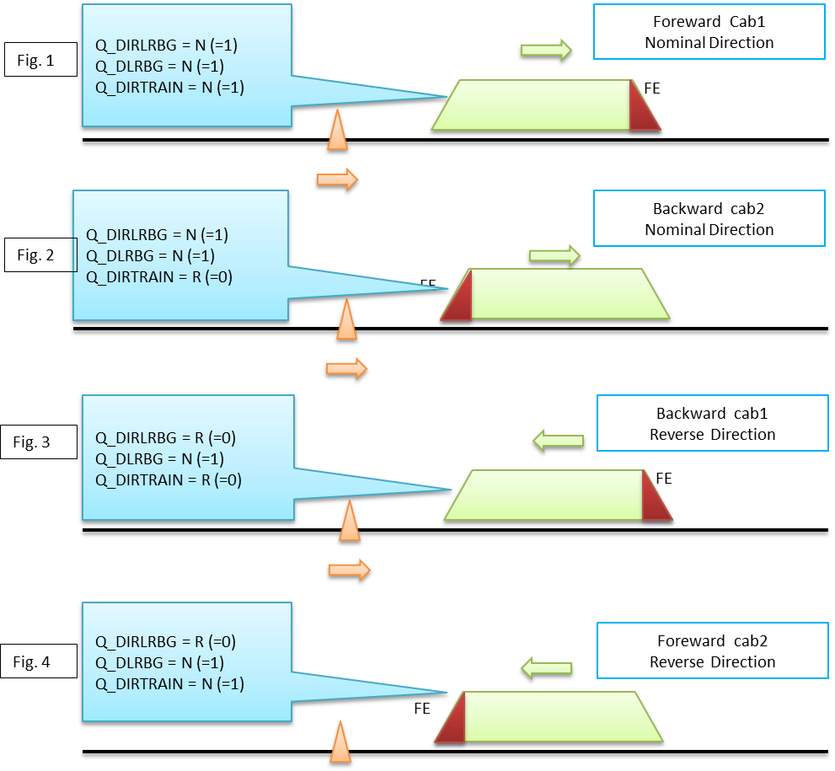

Qualifier overview

Definition of external variables :
The Clock of period 10 ms provides a “Time_Stamp” for any external variable.

The MMU (odomery) provides the following MMU_Data at the beginning of each real time cycle :
- Coordinate : 3 absolute counters of distance :
  - C_estimate : nominal estimated value, so-called “Cn”,
  - C_doubt-over : maximal value, so-called “Cmax”,
  - C_doubt-under : minimal value. so-called ”Cmin”.
- Speed : vital speed so-called “Vn”,
- Acceleration : not vital (?) so-callled ”Acc”,
- Motion_State : vital boolean so-called “Motion”,
- Motion_Direction : vital boolean so-called “Q_DIRTRAIN”,
- Time_Stamp : Timer value “Tn” when evaluating MMU Data ( Cn, Vn, Tn).

The BTM ( balise_reader) provides 1 up to 8 telegrams composed of :
- Telegram Tel_k, with k=1..8,
- Time_Stamp Tk, with k=1..8.

The timing is described hereafter with 4 balises read over 3 real-time cycles :

B-1
Tel-1
T1
C1 ?
B-2
Tel-2
T2
C2 ?
B-3
Tel-3
T3
C3 ?
B-4
Tel-4
T4
C4 ?
Cycle_n
Cn, Vn
Tn
Cycle_n+1
Cn+1, Vn+1
Tn+1
Cycle_n+2
Cn+2, Vn+2
Tn+2
Time
Distance
MMU (odometry) gives Coordinate values with speed and time-stamp at beginning of each real time cycle
BTM (balise reader) gives Telegrams and time stamp when balise axle and antenna axle are alined

Objective is to estimate Coordinate values at each balise axle.

- Cycle “n” : LRBG is positionned by C0,
  - MMU provides Cn, Vn, Tn,
  - BTM has provided Tel-1, T1,
  - Balise B1 position is : C1 = Cn – Vn * (Tn – T1),
  - Compute C1 with Doubt-Over and Doubt-Under.

- Cycle “n+1” : LRBG is still positionned by C0,
  - MMU provides Cn+1, Vn+1, Tn+1,
  - BTM has provided Tel-2, T2,
  - Balise B2 position is : C2 = Cn+1 – Vn+1 * (Tn+1 – T2),
  - Compute C2 with Doubt-Over and Doubt-Under.

- Cycle “N+2” : LRBG is still positionned by C0,
  - MMU provides Cn+2, Vn+2, Tn+2,
  - BTM has provided Tel-3, Tel-4, T3, T4,
  - Balise B3 position is : C3 = Cn+2 – Vn+2 * (Tn+2 – T3).
  - Balise B4 position is : C4 = Cn+2 – Vn+2 * (Tn+2 – T4),
  - Compute C3 and C4 with Doubt-Over and Doubt-Under.

- IF (Tel-1, Tel-2, Tel-3, Tel-4) are all consistant THEN :
  - Balise B1 becomes LRBG,
  - Reference position is now C1 instead of C0,
  - Order is given to MMU to restore inaccuracy at minimum,
  - Message composed of { Tel-1, Tel-2, Tel-3, Tel-4 } can be stored.

Emergency Stop
See subset-026 chap3.10. Only in level 2.

Speed and Distance Monitoring

Computation of Deceleration and Brake Build up Time
See subset-026 chap3.13.6.

MRSP computation
See subset-026 chap3.13.7.

Computation of Target and Curves
See Excel Model on EB curves.

Supervision Limits Computation

Ceiling Speed Monitoring

Target Speed Monitoring

Release Speed Monitoring

Protection against undesirable movement

Roll Away

Reverse

Standstill

Mode Management
See State Machine Diagram of Intercity project.

Brake command handling

Special Function

Version Management

SysML First Draft

First Level IBD
Hereafter is a SysML “IBD” first draft of EVC , with boxes out of Scade Control in yellow.:

Messages
Command / Control
To Position Train
Balise Content (BTM)
Odometry MMU
Train Data
EVC
Fixed Values
To Store System Data
To check and Store Balise Content
To Store Track Description in Database & Set of Variables
National Values
To Achieve Processes
DMI Data
To Manage DMI
Radio Message
To check and Store Radio Message
TIU Data
To Manage TIU
Additional Data (changeable on-board)
Orders / Display
Train Position & Speed (Loc_Report)
Time-Stamp
Dynamic Database & Set of Variables
Linking and
re-positionning
System Data
Packets
A1
A8
A2
A3
A4
A5
A6
A7
Packets by radio

IBD “EVC” of First Level
Boxes A1, A2, A3 and A4 are dedicated to data management with the objective of restauring expensed database..
Boxe A5 is dedicated to define all processes.
Boxes A6, A7 and A8 are technical function related to devices.

Second Level
Both boxes “To Check and Store Balise Content” and “To Store Track Description in Database” are using the schematic dynamic database matrix as follows :

General

BG_nPositionLinkingOrientat.Innacur.TrackCondPos.Param.Asafe9,81*grdMRSPOthers“““““Grade“Value“““SSP“““““

BG_n+1PositionLinkingOrientat.Innacur.SSPPos.ValueAsafe9,81*grdMRSPOthers“““““Grade“““““SSP“““““

BG_n+2PositionLinking

EOAPos.VeoaAsafe9,81*grdMRSPDP“0“““OL“0“““
BG_n+3PositionLinkingSSPPos.ValueAsafe9,81*grdMRSPOthers“““““Grade“““““SSP“““““
xxx

-1%
60 km/h
80 km/h

2%
45 km/h
Track Layout
Type Position Value Asafe Grd Mrsp
60 km/h

-0,5%
100 km/h
LOA
LRBG

Dynamic Database of “EVC”

Comments

- Assuming the hereunder matrix, the convention is :

  - Direction of travel is top to down, whatever is the direction of travel or orientation,
  - Dimension is enough to keep in memory :
      - the data related to the last 8 passed balises,
      - and the data related to 8 linked balises as anticipation,
      - only packets in correct orientation are stored.
  - The 3 first columns are filled by packet data :
      - Type is packet identity,
      - Position is distance from related LRBG,
      - Value is data related to the type,
      - In case of iteration, as much lines as necessary are filled up,
      - Line are classified by increasing position in relation with orientation.
  - The 3 other columns are computed once classification is achieved :
      - Asafe : emergency brake deceleration, can be a function of speed ) and other data (adhesion factor),
      - Grd : gravitation acceleration or deceleration, depend on related packet (gradient),
      - Mrsp : depends on numerous packet.
  - Other columns can be added for energy computation.

  - Assuming that message received through BG_n is acting as LRBG :
    - Linking packet is covering 3 BG (BG_n+1, BG_n+2, BG_n+3),
    - MA packet defines an EOA close to BG_n+2
    - BG_n+3 is in reverse orientation, meaning a possible change of track,
    - SSP and Gradient packets are enough to cover the track over the EOA (consistency criteria),
    - EOA indicates that route signal is at stop.
    - Assuming later on, when overpassing the BG_n+1 acting as new LRBG :
  - Linking is verified by Identity and Position regarding the permitted window,

Management of “Balises Linked” :
It is assumed that “Linked Balises” authorise the following features :

    - when any linked balise is overpassed and consistent, a re-positioning operation is proceeded with cancellation of positioning error (max- min = 1 meter) and this balise becomes the new origine of distance (new LRBG) for further computations.

    - “Linking Information” may be used or not. If not used, (not present), no checking of position is achieved when error is cancelled.

    - passed information remained unchanged in order to take them into account as long as necessary,

    - in level 1, downstream information are refreshed as soon as new LRBG is set in place.

    - in level 2, downstream information remained unchanged up to radio response with a new track description related to new LRBG.

    - in case of TSR, information packet need to be set again as long as no revocation has ocurred.

Management of “Balises Unlinked” :
It is assumed that “Unlinked Balises” does not authorise the following features :
Balise groups, which are marked as unlinked, shall never be used as LRBG
Justification: The location of an unlinked balise group, or the balise group itself, may not be known to the RBC

Algorithm of Box A2
Compressed data are split in telegram whose structure permits to recover decompressed data.
Telegram structure is : one header of 50 bits followed by one set of data of 780 bits (or 160 bits).
This algorithm is part of data decompression and should not be under the control of Scade.
This algorithm is activated at each real time cycle.

Inputs are :
Cn is the distance counter at cycle “n”, coming from MMU,
Vn is the speed at cycle “n”, coming from MMU,
Tn is the time counter at cycle “n”, coming from Clock,
“k” is the ranking (ie : order of receiving) for one received telegram and can be 1 up to 8,
- Tel(k) is the telegram “k”, coming from BTM,
- T(k) is the date of telegram “k”, coming from BTM,

Outputs are :
Id-BG = Identifier of BG is composed of NID-C and NID-BG
Orient-BG = { Nominal / Reverse } is used to filter packets of same orientation
Q-Link = { (0 : not linked), (1 : linked) }
Mess-BG = vector of telegram received at real time cycle “n”,
Each vector Mess-n is composed of 8 records composed of :
Set of data packets = { (Ident, Size, Data)…}
Dup = { (00 : no_dup) / (01 : next_dup) / (10 : prev_dup) / (11 : spare ) }
Rec = { (0 : no ) / (1 : yes) }
Pos = Counter of distance

Packets of Tel(0)
Packets of Tel(1)
Packets of Tel(6)
Packets of Tel(7)
Dup of Tel(0)
Dup of Tel(1)
Dup of Tel(6)
Dup of Tel(7)
Rec of Tel(0)
Rec of Tel(1)
Rec of Tel(6)
Rec of Tel(7)
Pos of Tel(0)
Pos of Tel(1)
Pos of Tel(6)
Pos of Tel(7)
Orientation Reverse
Orientation Nominal

“Compilation of telegram(s) into one message (A2) ”
Parameters related to position needs to be computed as follows :
- Pos(k) is the computated position when receiving telegram “k” :
Pos(k) := Cn – Vn*(T(k)-Tn)

Parameters related to telegram needs to be extracted from header :
N_PIG(k) : position in the group of telegram whose ranking is ”k”, position can be 0 up to 7,
N_PIG(1) = position of 1st balise = 0 in nominal orientation (last in reverse),
N_TOTAL : total number of telegram whatever is “k”, can be 0 up to 7.
N_TOTAL = position of 1st balise = Nbm1 in reverse orientation (last in nominal),
M_DUP(k) : duplication indicator of telegram “k” : 01 for next in nominal / 10 in reverse,
M_MCOUNT(k) : telegram fitting,
NID_BG(k) : identifier of LRBG, permits to detect change of BG,
Q_LINK(k) : link indicator.

Criteria of acceptance for any telegram :
First-balise criteria : change of M_COUNT THEN Mess(n) = EMPTY for n=0..7
Nominal direction criteria : Cn = (N_PIG(1) = 0) OR [ (N_PIG(1) =1) AND (M_DUP(1) =10) ].
Reverse direction criteria : Cr = (N_PIG(1) = Nbm1) OR [ (N_PIG(1) = Nbm1-1) AND (M_DUP(1) = 01) ].
Current-balise criteria : 0 =< N_PIG(k) =< Nbm1 THEN Mess(N_PIG(k)) = Tel(k)
Nominal Last-balise criteria : (N_PIG(k) = Nbm1) is End-BG in nominal
Reverse Last-balise criteria : (N_PIG(k) = 0 is End-BG in reverse

Criteria of completeness :
When End-BG is true, we should study all case in both nominal and reverse orientation with duplication only authorised for odd number of balise :
Case no balise : Complete_BG := false
Case 1 balise : Complete_BG := Rec(0) AND (Dup(0)=00)
Case 2 balises : Complete_BG := { Rec(0) AND [ Rec(1) OR (Dup(0)=01) ] }
OR { Rec(1) AND [ Rec(0) OR (Dup(1)=10) ] }
Case 3 balises : Complete_BG := Rec(0) AND Rec(1) AND Rec(2)
Case 4 balises : Complete_BG := { { Rec(0) AND [ Rec(1) OR (Dup(0)=01) ] }
OR { Rec(1) AND [ Rec(0) OR (Dup(1)=10) ] } }
AND { { Rec(2) AND [ Rec(3) OR (Dup(1)=01) ]
OR { Rec(3) AND [ Rec(2) OR (Dup(3)=10) ] }
Etc..
Criteria of cancellation of duplication when End-BG is true :
Each time a telegram has been received with Dup=01, the next telegram has to be cancelled in order to avoid replication within database.

The algorithm hereafter permits to build a complete message by receiving telegram by telegram.

Id change ?
No, same BG
Yes,New BG same BG
1st balise in Nominal ?
1st balise in Reverse ?
Yes
No
Noo
Initialization
store Position Id
store Orientation store Telegram
store DUP
Yes
store Telegram
store DUP
Last Balise ?
Message complete ?
Eliminate Redundancy
Build and Store Message
Store Reference Position
Balise in Nominal ?
Balise in Reverse ?
No
Noo
Yes
Yes
No
Noo
Telegram ?
No
Yes
STOP
START
Yes

“To Chek and Store Balise Telegram (A2) ”

Notice 1 :The test “Id. Change ?” includes:
- A change of NID_BG,
- A change of NID_Country,
- A distance between balise over 5 m,
- A distance between balise lower 3m.

Notice_2 : The test “1st balise” includes :
- N_PIG is equal “1”
- N_PIG is equal “2” if redundancy of balise 1.

Algorithm of Box A3
With radio, each message is received in one piece (no telegram). .

It exists various types of radio messages

All of them are composed of :
- Identifier of message,
- Dedicated variables,
- Standard packets.

Algorithm of Box A4
TBD

To Position Train
To see what is done by other partners…

A proposed draft is given hereafter :

To Position Train A.8
Train Position & Speed
Synchro Odo / Balise
Linking and
re-positionning
Linking (input) :
Id of next BG
Distance to next BG
Orientation of next BG
(Q_LINKORIENTATION)
Inaccuracy of next BG
Positioning (output) :
Id of last BG (NID_LRBG)
Distance since LRBG (D_LRBG)
Orientation of LR BG (Q_DIRLRBG)
Train Position related LRBG (Q_DLRBG)
L_DOUBTOVER
L_DOUBTUNDER
V_TRAIN
Train Running related LRBG
(Q_DIRTRAIN)

To Up-date when overpassing linked balise group
To Up-date when overpassing re-positioning balise
To Up-date at every real time cycle
To Position when overpassing un-linked balise group
Re-Positioning (input) :
Id of BG
Distance to next BG
Orientation of next BG
Odometry (Input) :
Counter Increasing
Counter decreasing
Counter standstill
Counter value
Speed (V_TRAIN)
Positioning (input) :
Id of last BG
Distance since last BG
Orientation of last BG

“To Position Train”

Comments :

- To Up-date at every real time cycle :
  - Input are:
    - Counter of odometry including :
      - Value, Increasing, Decreasing, Standstill,
      - Speed.
  - Output are up-dated by :
    - D_LRBG = ( Counter – Counter0 ) nom, min, max
      - Counter is the current counter of odometry,
      - Counter0 is the counter value when over-passing LRBG.
    - NID_LRBG = unchanged,
    - Q_DIRLRBG = unchanged,
    - Q_DLRBG = inverted if D_LRBG changes of sign,
    - Q_DIRTRAIN = inverted if D_LRBG changes of variation sign,
    - L_DOUBTOVER = D_LRBG max ,
    - L_DOUBTUNDER = D_LRBG min,
    - V_TRAIN = Speed (MMU)

- To Position when overpassing balise :

  - If balise is “Re-positioning”, only D_LRBG is updated by :
    - D_LRBG = D_LINK – L_SECTION

  - If balise is linked with previous one, checking with parameters in red must be true :
    - | ( D_LRBG – L_DOUBTOVER < D_LINK ,
    - | ( D_LRBG + L_DOUBTUNDER > D_LINK ),
    - NID_LRBG = NID_BG,
    - Q_DIRLRBG = Q_LINKORIENTATION.

  - Output are estimated by :
    - Counter0 = Counter,
    - D_LRBG = 0,
    - NID_LRBG = new,
    - Q_DIRLRBG = new,
    - Q_DLRBG = inverted if D_LRBG changes of sign,
    - Q_DIRTRAIN = Q_DIRLRBG,
    - L_DOUBTOVER = LRBG_Inaccuracy,
    - L_DOUBTUNDER = LRBG_Inaccuracy ,
    - V_TRAIN = provided by odometry

To Achieve Processes
See SyML IBD draft hereafter.

SRS-026 3-13-14-1
SRS-026 3-12 & 3-15
SRS-026 3-12-4 & SRS-026 4
SRS-026 3-13-14-2
Command / Control
To Achieve Processes A.5
Orders / Display
Messages
Train Position
& Speed
System Data
Classify DataBase
& MRSP Computation
Asafe
Computation
Supervision Limits Computation
Target and Curves Computation
Database
Mode and Level
Protection
Brake Handling
Version Management
Special & Radio
Functions
Curves & Target
MRSP (x)
Asafe (x, v )
SvL
& over speed
& overide
Mode request
& EB request
Mode & Level
Defaut
SRS-026 3-13-3
SRS-026 3-13-8
SRS-026 3-13-9 & 3-13-10
SRS-026 3-13-7
Orders / Display
SRS-026 3-13-17
A5.2
A5.3
A5.1
A5.5 & 6
A5.4
A5.7

“To Achieve EVC Process”
The breakdown structure makes to appear a great number of boxes, and each box needs to be analysed through SysML IBD ( Mainly Special and Radio Functions).

The great box in blue corresponds to “SRS-026 3-13” which is so-called “Speed and Distance Monitoring”. The breakdown structure appears within the IBD.

The small box in blue corresponds to “SRS-026 3-12” and to “SRS-026 3-15” which is so-called “Special Functions” ( 1 : mandatory, 2 : optional ).

Breakdown Structure of EVC

General

First Level

The breakdown structure of IBD “first level” could be established as hereafter.

- A1 : To Store System Data

- A2 : To Check and Store Balise Data

- A3 : To Check and Store Radio Messages

- A4 : To Store Track Description in Database

- A5 : To Achieve Processes

- A6 : To Manage DMI

- A7 : To Manage TIU

- A8 : To Position Train

Second Level

The final breakdown structure of IBD “second level” could be established as hereafter, by distinguishing mandatory and secondary functions.

Mandatory :

- A5.1 : Speed and Distance Monitoring :
  - A5.1.1 : Asafe( x, v ) computation,
  - A5.1.2 : MRSP(x ) computation,
  - A5.1.3 : Target and Curves computation,
  - A5.1.4 : Supervision Limits computation,
  - A5.1.5 : Commands.

- A5.2 : Protection :
  - A5.2.1: Emergency Stop (UES, CES, revocation, inhibition)
  - A5.2.2 : Track ahead Free,
  - A5.2.3 : MA Shorten,
  - A5.2.4 : Roll Away Protection,
  - A5.2.5 : Reverse Movement Protection,
  - A5.2.6 : Standstill Supervision.

- A5.3 : Mode and Level Monitoring :
  - A5.3.1: Level Handling,
  - A5.3.2 : Mode Handling.

- A5.4 : Brake Command Handling.

Secondary :

- A5.5 : Special Functions 1 :
  - A.5.5.1 : Track Conditions Handling,
  - A.5.5.2 : Route Suitability,
  - A.5.5.3 : Text Transmission,
  - A.5.5.4 : Level Crossing.

- A5.6 : Special Functions 2 :
  - A.5.6.1 : RBC Handover,
  - A.5.6.2 : Non Leading Handling,
  - A.5.6.3 : Splitting/ joining,
  - A.5.6.4 : Reversing Movement,
  - A.5.6.5 : National Systems Handling,
  - A.5.6.6 : Tolerance of Big Metal Mass,
  - A.5.6.7 : Virtual Balise,
  - A.5.6.8 : Route Advanced Display.

- A.5.7 : Version Management.

Development of A5.1 ( example)

references
UNISIG Subset_026 version_3.3.0
Chapter 3 : ERTMS / ETCS Principes
Chapter 4 : ERTMS / ETCS Modes
Chapter 5 : ERTMS / ETCS Procedures
Chapter 7 : ERTMS / ETCS Language

overview
[SRS-026-chapter : 3.13.9.3]
“Speed and Distance Monitoring” (A5.1) consists in computation of EBD, EBI, SBD and SBI curves.
“GUI curve” is not addressed.

The use of an Excel database is involved in this exercise.
The technics to fill up the database starting from balise contents is not approached.

The structure of the database is defined and Excel capabilities such as classification of data lists following increasing or decreasing abscissa are used.
We shall start from a typical BG of 2 or 3 balises that are crossed by one train in level 1.

This BG will provide basic data packets such as :
- National values,
- Movement Authorization,
- Balise linking,
- Speed Profile,
- Gradient Profile,
- Level Order,
- Temporary Speed Restriction.
- etc…

Context of Speed and Distance Monitoring
The context is defined with SysML diagram through one BDD (Block Diagram Definition) and several IBD (Internal Block Diagram) that will need to be linked with other parts of the OpenETCS definition.

The Block Diagram Definition should be composed of functions related to chapter 13 of the subset-026 chapter 3.

The Speed and Distance Monitoring ( Function A5.1) is one IBD of BDD :

Speed and Distance
Monitoring A5.1
(SRS-026 chap3-13)
Train Length
National Values
SSP Profile
Gradient Profile
Temporary Speed Restriction
Track Condition Request
Speed & Position & LRBG
LOA, Veoa, DP, OL
Mode Profile
Emergency Brake Curves
Service Brake Curves, S, W, P, I
Overspeeding
Fixed Values
Overiding
Target
Request Mode

Block A51 “Speed and Distance Monitoring”

Inputs :
- From “Balise Decoding” :
    - National Values,
    - SSP Profile,
    - Gradient Profile,
    - Temporary Speed Restriction,
    - LOA, Veoa, Danger Point, Overlap.
- From “Internal” :
    - Fixed Values,
    - Train Length,
    - Request Mode,
  - Track Condition Request.

Outputs :
- Emergency Brake Curves,
- Service Brake Curves (Service, Warning, Permitted, Indication),
- Overspeeding (cell and target),
- Overiding,
- Target,
- Release Speed.

Orders / Display
Train Position
& Speed
System Data
Classify DataBase
& MRSP Computation
Asafe
Computation
Supervision Limits Computation
Target and Curves Computation
Database
Curves & Target
MRSP (x)
Asafe (x, v )
SvL
& over speed
& overide
SRS-026 3-13-3
SRS-026 3-13-8
SRS-026 3-13-9 & 3-13-10
SRS-026 3-13-7
Orders / Display
A5.1
Detail of Block A51 “Speed and Distance Monitoring”

Example of Balise Group in level 1
We shall show an example of database configuration for a Balise Group in level 1.
- In first, we shall deploy the database following the singular points that are involved within the BG. We shall see that is not fully meeting the requirement of an EB deceleration variable with the speed.
- In second, we shall deploy the database by quantum of 10 meters.
Definition file of such BG is given within excel file, chapter 5.7.

EB Supervision Curve

All parameters for braking to target supervision limits for EBD curve are defined within the drawing hereafter :

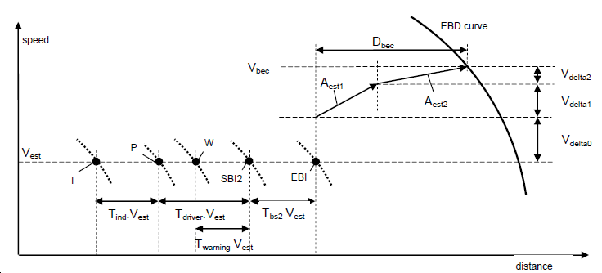
Origin :
,x0, v0, h0
Braking :
xb, vb, hb
Target :
x1, v1, h1

EB Supervision Computation

It is defined 3 particular locations :
- Origin :
  - x0 : location where the EB intervenes,
  - v0 : speed at location x0, so-called “Vest”, can be increased by inaccuracy,
  - h0 : hight of gravity centre at x0.
- Braking :
  - xb : location where the EB is active after two phases of transition,
  - vb : speed at location xb, is v0 increased after 2 phases of transition,
  - hb : hight of gravity centre at xb.
- Target :
  - x1 : target location,
  - v1 : target speedn
  - h1 : hight of gravity centre at target.

The next computation will be done through physical mechanic theory in “Energy” by mass unit (m²/s²) between origin and target. To define the EB supervision limits, we put the following equation :

(Brake_Energy) + (Potential_Variation_Energy) > (Kinetic Variation Energy) + (Response_Correction)

Cumul_EB > Cumul_K

With the following development :

  - Kinetic Variation Energy = ½ (v0² - v1²)
    - this value concerns the total mass : M * (1+alfa)
    - alfa can be a function of position “x”.

  - Brake Energy = (x1 – x0) * Aeb
    - this value concerns the total mass : M * (1+alfa)
    - Aeb is the average value of the function Asafe(x,v)
    - Asafe(x,v) needs to be integrated between x0 and x1
    - what about v ? (speed at origin x0 or something else )

  - Response_Correction = ½ [ (Aest1* T1)² + (Aest2*T2)²] +(Debc * Aeb)
    - response is in 2 phases, lasting T1 and T2,
    - the running distance is so-called Debc,
    - brake energy over Debc must be added to kinetic energy
    - power energy (Aest1 and Aest2) must be added too.

  - Potential _Variation_Energy = (h1 – h0) * g / Alpha
    - this value concerns only the mass M,
    - g = 9,81 m/s² must be taken into account,
    - potential energy must be compensated by division with Alpha = 1+alpha,
    - h1 – h0 is the integration of function Grade(x) between x0 and x1.

EB Supervision Excel File

The use of an Excel database is involved in this exercise in 3 steps :
  - Step 1 : to acquire data from balise content,
  - Step 2 : to classify acquired data into another file,
  - Step 3 : to simul.

Step 1 Excel File :
______________
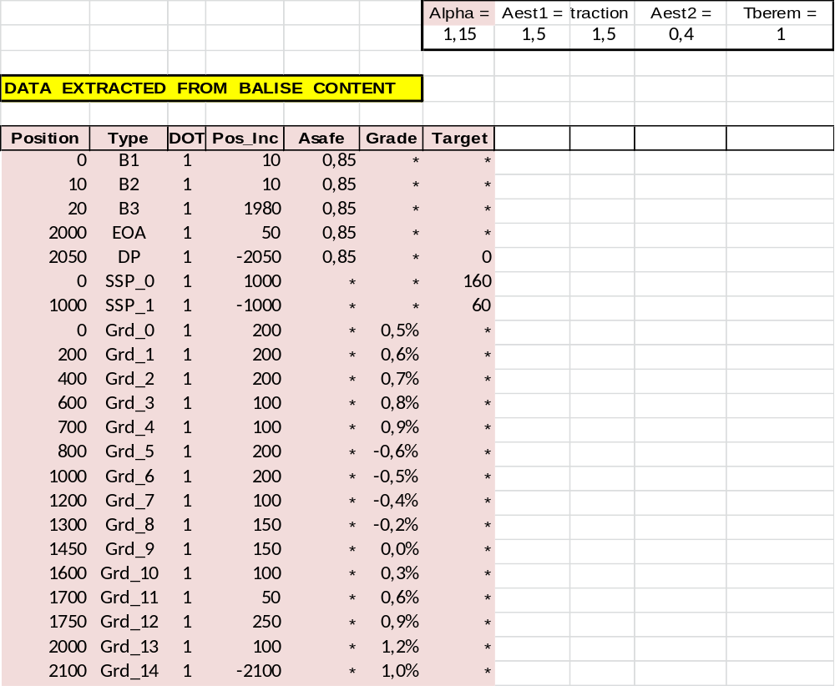

Position is the distance of singular point from the reference balise B1,
Type is the nature of singular point,
DOT is the Direction of Travel.
Pos. Inc. is the incremental position to the next singular point.
Asafe is the safe deceleration value of the Emergency Braking, related to increment.
Grade is the slope value which permits hight computation, related toincrement.
Target is the singular point of MRSP or a DP which can be a potential target.

Step 2 : singular point of database are classified following increasing position.

Step 3 : computation of final parameters.
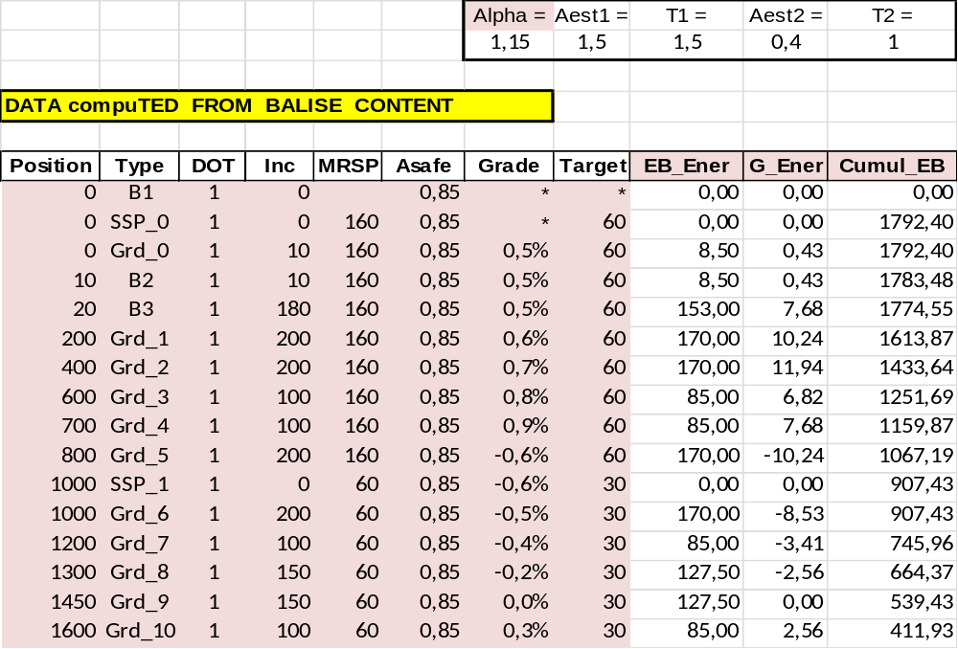
EB_Ener is the Emergency Brake Incremental Energy.
G_Ener is the Gravitation Incremental Energy.
Cumul_EB is the sum of EB and G energy variation from target DP to current position.
K_Ener is the Kinetic Energy variation from target DP to current position.
Debc is the running distance during both transition.
Corr_E is the increased transition energy.
Cumul_K is the sum of Kinetic and Transition Increased Energy.
E_Maxi is the minimum of both “Cumul”.

SSP_1 60 km/h is intermediate target and DP is the final target.

EB Supervision per Quantum

We come back on previous equations :

(Brake_Energy) + (Potential_Variation_Energy) > (Kinetic Variation Energy) + (Response_Correction)

In order to eliminate the response correction, we shall take in consideration the energy between target ”x1” and current location “xb”. That gives :

(Brake_Energy_B) + (Potential_Variation_Energy_B) >= (Kinetic Variation Energy_B)

and vb <= MRSP(xb)

With the following development :
  - Kinetic Variation Energy B = ½ (vb² - v1²) ( v1 is target, vb is current v )

  - Brake Energy B = (x1 – xb) * Aeb (integration from xb to x1)

  - Potential _Variation_Energy_B =(h1 – hb) * g / Alpha (integration xb – x1)

The process is to define “vb” from the target location (basically the Danger Point DP) up to the balise location. Then we have at the begining :

  - ½ (vb² - v1²) = (x1 – xb) * Aeb + (h1 – hb) * g / Alpha or
  - vb² = v1² + 2 * [(x1 – xb) * Aeb + (h1 – hb) * g / Alpha] and
  - vb <= MRSP(xb)

Starting from DP location (or EOA), to define “x1”,
v1 = 0 or Vsig,
h1 =0
Then to compute vb for each “xb” iteration, with a limitation by MRSP.
When previous MRST is higher, we have a new target.

Then the EBI curve can be computed through Debc and V_delta computation:
V_delta = Aest1*T1 + Aest2*T2
v0 = vb – V_delta
Debc = ½ ( Aest1 * T1² + Aest2 * T2² ) + v0 * (T1 + T2)
x0 = xb – Debc
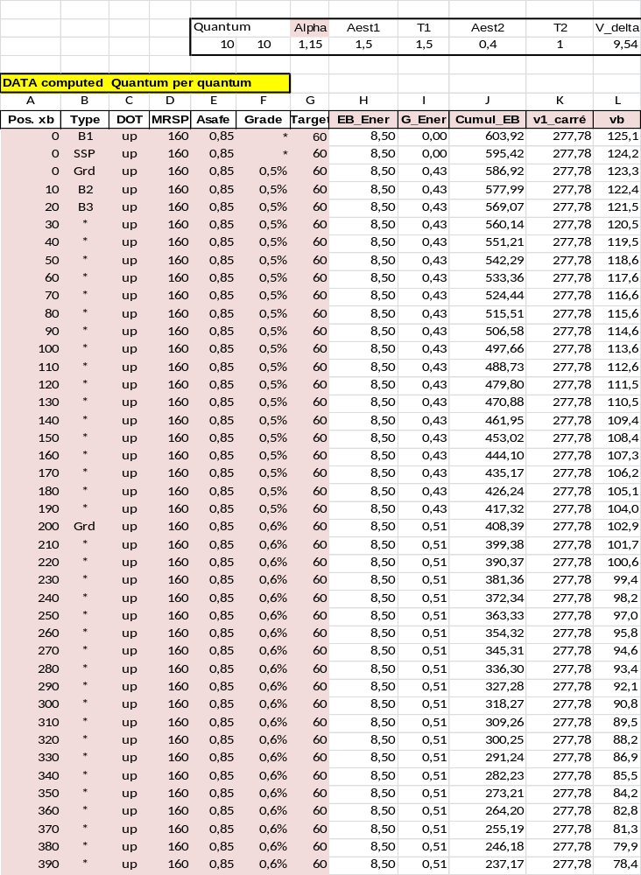Variables of speed limit
Pos. xb is the position of control at speed vb, incremental quantum=10 m. { m }

Type is the type of singular point ( “ * ”means no type).

DOT is up or down.

MRSP is the Most Restrictive Speed Profile ( compile SSP, TSR, Vmax..). { km/h }

Asafe is safe deceleration value, is a function of x and v0. { m/s² }
Formula : Asafe(n) = SI((v0 < 60); 0,80; 0,85)

Grade is slope grade, positive in uphill.

Target is the closest target speed, it can be : MRSP reduction, EOA, DP. { km/h }

EB_Ener is the Emergency Brake Incremental Energy. { m²/s² }
Formula : EB_Ener(n) = Asafe(n) * Quantum

G_Ener is the Grade Incremental Energy. { m²/s² }
Formula : G_Ener(n) = Grade * 9,81 * Quantum

Cumul_EB is cumul “EB_Ener +G_Ener”, since smallest target energy. { m²/s² }
Formula : Cumul_EB(n) = MIN( (Cumul_EB(n+1) + EB_Ener + G_Ener) ; ½ * (MRSP/3,6)² )

v1_carré is 2 times Kinetic energy of smallest target. { m²/s² }
Formula : v1_carré = ½ Target²

vb is max speed to respect smallest target without response time. { km/h }
Formula : vb = ( (RACINE( 2 * Cumul_EB )) * 3,6 )

v_delta is speed variation during the transition phase T1+ T2. { km/h }
Formula : v_delta = ((Aest1*T1) + (Aest2*T2)) * 3,6 )

v0 is max speed to respect smallest target with response time. { km/h }
Formula : v0 = vb – v_delta

Debc is running distance during response time. { m }
Formula : d = ½ ( (Aest1*T1²) + (Aest2*T2²) ) + ( Aest1* T1 * T2 )
Formula : Debc = d + (v0 * (T1+T2) / 3,6)

x0 is max position to respect smallest target with response time. { m }
Formula : x0 = xb - Debc

Track configuration

Simple Track Configuration is:

Balise : B1, B2, B3.

SSP : 160 km/h at position 0, 60km/h at position 160.

Grade changes at position 0, 200, 500, 610, 710, 820, 920, 1030, 1040, 1050,1080.

EOA at position 1060 with 30 km/h.

DP at position 1070.

Train Simulation (for model only)

Pos.xb is geographical milestone quantum per quantum of 10m = Pos(n)

Pos(0) is initiale position = 0 => Pos(n) = Pos(n-1) + 10
Pos(n+1) = Pos( n) +10

Aest is train acceleration => Aest( n ) = f ( v, n )

Vest is train speed at Pos(n) =>
Vest(n+1) = RACINE( (20 * Aest( n) ) + Vest(n)² )

Tdelta is time to reach Pos(n+1) and Vest(n+1)
Tdelta = (Vest(n+1) – Vest(n) ) / Aest(n)
Tdelta = { RACINE [ (20 * Aest( n) ) + Vest(n)² ] – Vest(n) } / Aest(n)

Additional Issue on EB Supervision per Singular Point

This additional issue aims to address one change of EB deceleration value between two singular points named “A” and “B”.

The initial EB deceleration value is AEB0 and is reduced to AEB1 when the train speed is over “Vs”.

The first step of computation consists in finding the location of Xs related to Vs on the curve AEB0.

The second step consists in evaluating the speed Vc at location “C” or “B” in reason of AEB1 lower than AEB0.

Xc=Xb
Vc= ?
AEB1
ENERc
Xa
Va
AEBa
ENERa
Xs
Vs
Xb
Vb
AEB0
ENERb
AEB0
AEB1
Vs
S
C
B
A

AEB change between 2 singular points

Assuming an interval between 2 singular location “A” and “B”:

On this interval, the deceleration due to gradient is constant, is so-called GRD,
In case of change of gradient, the interval is split into 2 parts at given location.
The interval is limited by 2 singular location “A” and ”B”.

Assuming singular location “A” with:
- Xa = position of “A”
- Va = speed control at “A”
- AEB0 = initial EB deceleration (at “A”)
- ENERa = energy countdown at ”A”
Assuming singular location “B” with:
- Xb = position of “B”
- Vb = speed control at “B”
- AEB0 = initial EB deceleration (suppose same value at “A”)
- ENERb = energy countdown at “B” with same AEB0
Taking into account the reduction of deceleration at speed “Vs”, we have to estimate :
- Xs = location where speed control is “Vs”
  - Xs solution of equation : ½ * (Vs² - Va²) = (Xa - Xs) * AEB0
  - or Xs = Xa - (Vs² - Va²) / (2 * AEB0)
  - or Xs = Xa + ( Va² / (2 * AEB0)) – ( Vs² / (2 * AEB0))
- To replace singular location “B” by “C” :
  - Xc = Xb
  - Vc solution of equation : ½ * (Vc² - Vs²) = (Xs - Xc) * AEB1
  - or Vc² = Vs² + 2 * AEB1* (Xs – Xc)
- At the final, “B” is replace by “C” at the same location with Vc² computed by equation :

Vc² = Vs² + ( 2 * AEB1* Xs ) – ( 2 * AEB1 * Xc )

Vc² = Vs² + ( 2 * AEB1* (Xa – Xc)) - ((Vs² - Va²) * AEB1 / AEB0)

ENERc = ½ * Vc²

Impact of gradient through GRD = Grade * 9,81 / Alpha :

Vc² = Vs² + [ 2 * (AEB1+GRD) * (Xa – Xc) ] – [ (Vs² - Va²) * (AEB1+GRD) / AEB0+GRD) ]

Verification of formula :

If AEB0 = AEB1 => Vc² = Vs² - Vs² + Va² + 2 * AEB0 * (Xa – Xc)

or 0 = Va² - Vc² + 2 * AEB0 * (Xa – Xc)

Application :

AEB0 = 1; AEB1= 0.7; GRD =0; Vs = 20 |=> Xs = 400 + (10² / 2) – (20² / 2) = 50

Xa = 400; Va = 10; AEB0 = 1; ENERa = 50

Xb = 0; Vb = 30; AEB0 = 1; ENERb = 450 |=> Vc² = 20² + 2 * 0,7 *50 = 470 |=> Vc = 21,7

END OF DOCUMENT

